Erection of House at Loch Borralan, Ledmore, Lairg, Sutherland
(Planning Application 05/00213/FULSU)

Archaeological Evaluation and Watching Brief

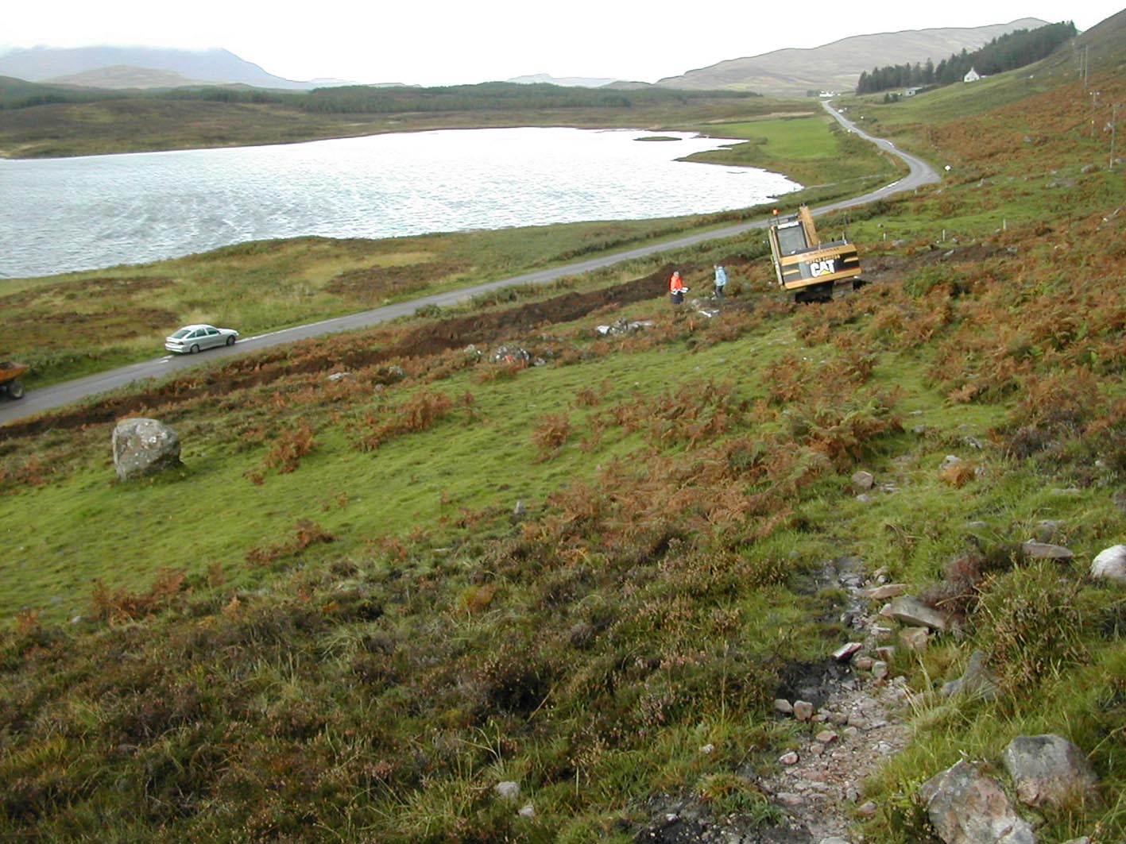

Catherine Dagg

for

R. Houldsworth
Ledbeg
By Lairg
Sutherland
IV27 4HJ

Erection of House at Loch Borralan, Ledmore, Lairg, Sutherland (Planning Application 05/00213/FULSU) Archaeological Evaluation and Watching Brief

- Background

An archaeological evaluation and watching brief was required on ground breaking work on the site of a house and associated infrastructure at NC 2610 1118, approximately 230m NW of the Altnacealgach Hotel on the north shore of Loch Borralan in Sutherland. This archaeological work is a condition of planning consent for the following reasons:

- The application area lies immediately to the NE of a Scheduled Ancient Monument:
Loch Borralan West, Chambered Cairn at NC 2603 1114, SAM 1766, SMR no. NC21SE0001

A second Scheduled Ancient Monument is located approximately100m east of the application area:

Loch Borralan East, Chambered Cairn at NC 2624 1118, SMR no. NC21SE0002

Another, unscheduled, chambered cairn is located approximately 400m SSE of the application area:
Loch Borralan Chambered Cairn, at NC 2655 1104, SMR no. NC21SE0006
The primary function of chambered cairns may not be the burial of the dead, given the scarcity of human remains in excavated cairns, and they may have more important functions as territorial markers or foci for communities. The presence of three cairns in a relatively small area indicates a strong Neolithic presence, which should also be represented by settlement remains. It is therefore possible that associated below-ground archaeological deposits survive in this area and some would be identified as nationally important. A number of later, possibly early modern archaeological features have also been noted in this area during field survey by RJ Mercer in 1989, although they were not located by later Ordnance Survey visitors

Archaeological assessment and recording is therefore required at this site because there is a potential for finds, features or deposits of archaeological significance to be discovered and damaged during site works. The programme of archaeological works will aim to identify any such features at the earliest possible stage so that they can be preserved, or if necessary recorded before destruction. This approach is intended to ensure that any archaeological features or finds on site are identified and recorded with minimum delay or disruption to the development.
- Methodology

The present programme of archaeological work consists of the following specific elements:

- A desk based assessment of the site
- A watching brief on all ground breaking work, including access track, hardstanding for caravan, soakaway and service connections, and the house site itself.

The watching brief was carried out on 28.9.05, in dry and clear weather conditions

- Scheduled Ancient Monuments

The Scheduled Area of Loch Borralan West, Chambered Cairn, SAM 1766 does not extend north of the road, and therefore the present development does not intrude into this area, and Scheduled Monument Consent was not required. Historic Scotland were consulted and raised no objection to the development. Concern was expressed that the development would impede the line of sight from one monument to the other, and while this was not considered likely as the house site lies to the west of the sight line, the potential visual impact of the development on the settings of the Scheduled Monuments was included in this evaluation.

4.0 Historical Background and Cartographic Evidence

The shores of Loch Borralan lie within the lands of Ledmore, the township of which was located to the NW, between the road junction and the confluence of the two rivers. A detailed study of the Assynt farms by John Home in 1774 indicates three small areas of corn land between the loch and the then, higher, route of the road between Assynt and Tain. One of these covers the small triangular promontory on which the chambered cairn is situated, and is marked as consisting of 3 acres, 2 roods. North of this, the steeper ground is marked as ‘steep braes yielding good grassy pasture and some birch trees’ The accompanying description of the farm of Ledmore describes most of the ground east of the township as ‘wet logged moss, excepting about the edge of the Loch and burn where there is a narrow strip of good grass. Altnacealgach is recorded as Sheeling no.1, described as lying ‘on the north side of Loch Borralan adjoining the march with Balnagowan’

In 1774 half of Ledmore was held as a tack by Alexander MacKenzie of Ardloch and consisted of eight households, the other half was occupied by Lieut. Alexander MacLeod and two other households, giving a total population of 52.

From 1793 to 1812 the tenancy of Ledmore was divided between a tacksman, Roderick MacKenzie, who sublet to a number of subtenants, and a roughly equal number of small tenants. The 1811 census for Assynt records 17 households for Ledmore and one at Auldan na Kalkack (Altnacealgach), giving a total population of 74. Apart from the pendicle of Altnacealgach, all the houses were concentrated at Ledmore township.

In 1812 Roderick MacKenzie took the let of Ledmore as a sheep farm and cleared the subtenants and small tenants, although some cottars were allowed to remain. Like most of the Assynt sheep farmers, Roderick MacKenzie failed and the farm was back in the estate’s hands by 1825.

The 1st edition Ordnance Survey map, published in 1878 does not indicate any of the chambered cairns. It does indicate a higher trackway which is presumably the original road, as recorded on Home’s survey, this runs at about the same contour as Loch Borralan East chambered cairn. It also records an enclosed and improved field on the loch shore to the NW end of the loch.

- The Watching Brief

  - Site Description

The area of the proposed development lies to the north of the road running along the shore of Loch Borralan West, at a point where the shoreline forms a small triangular promontory. It is on this promontory that the Loch Borralan chambered cairn is sited. The road follows the line of the first break of slope. Between this and a second break of slope is a strip of what appears to be improved ground, with a cover of grass rather than heather, although heavily colonised by bracken. (Photo no. 1) On the steeper slope above the higher break of slope the ground cover is heather, and there is a marked boundary between grass and heather at the east end of the site. Between the house site and the Altnacealgach Hotel the ground is wet with no indications of any improved areas. The possible route of a narrow, overgrown track was noted NW of the hotel. This became indistinct before reaching the house site, but may be the remains of the earlier road recorded on early maps.

The site is stony, with a number of glacially deposited boulders, some of which have what may be field clearance stones piled against them. Prior to the recent fencing of the site, cattle have eroded a number of routes east to the higher ground.

A fail dyke, of turf and rubble construction, was noted crossing the site to its SE corner. South of the road this dyke runs, east of the chambered cairn, to the loch shore. To the west of the site it is indistinct but probably runs above the improved ground to Ledmore where a number of sections of turf dyke are visible when the bracken has died back. However, within the present development area the improved ground continues above the dyke, suggesting an extension of cultivation at a date later than the construction of the dyke. In fact, the dyke appears to have been deliberately removed in some sections, where only larger boulders remain, and a jumble of large stones against the north side of the remaining section may be this removed material. (Photo no. 2)

  - Topsoil Stripping

A watching brief was carried out on topsoil stripping of the entire length of the access road, soakaway, house and hardstanding and proposed garage site. (Photos 3, 4)The following observations were made

- Soil Profile: the topsoil was a light, grey-brown soil, not peaty. Depth varied from more than 0.5m at the juncture of the access road with the public road, (Photo no. 5) to 0.2m at the top of the site, (Photo no. 6) as would be expected if cultivated soils were left without a vegetation cover. The observed boundary between grass and heather at the east end of the site was marked by a rapid change from the grey-brown soil to a peat topsoil lying directly on the subsoil gravels. This would appear to confirm this as the eastern boundary of the area of former cultivation. The subsoil was compacted, glacially deposited gravels containing some larger boulders.
- Finds: no finds were recovered from the topsoil.
- Fail Dyke: In order to retain as much as possible of the fail dyke as a feature, the route of the access road was altered slightly to cross the dyke at a section which, as noted above, had already been removed. This prevented the opportunity to investigate the profile and fill of the dyke. One end of the surviving section was exposed. This appeared to indicate that the rubble fill of the dyke was lying directly on the subsoil, and that the soil fill was not significantly different from the topsoil. (Photo no. 7)

  - Scheduled Ancient Monuments

As was obvious on the plan of the development, the house site does not lie on a direct line between the two chambered cairns and therefore will not have an adverse impact on the relationship between the two monuments. (Photo no. 8)

From Loch Borralan East chambered cairn the completed house is unlikely to be visible. From Loch Borralan West it will be a significant element looking NE, but will not impede lines of sight along the loch shore or to the horizon of the hills to the north and east. (Photo no. 9)

- Archaeological Conclusions

The evidence in the soils for former cultivation is consistent with the evidence from maps, notably Home’s survey in 1774. Home indicates a small, distinct, unenclosed cornfield of only 3.5 acres (1.42 hectares) running down to the shore. The detail of information in his plan of Ledmore and accompanying notes would suggest that if there were a dyke or if the cultivated area had been the entire strip along the shore, this would have been recorded. It therefore seems likely that there was an extension of the cultivable area after 1774, possibly linked to an increasing population (52 in 1774, 74 in 1811) It is unlikely that this land, the furthest from Ledmore township, would have continued in use after the removal of the greater part of the population in 1812.

A date for the abandonment of the arable ground in 1812 is consistent with the absence of small finds such as ceramics found in fields in use through the 19th century. A date for the bringing of the ground into cultivation is more difficult to ascertain without any dateable material. It is still possible that the location of the two chambered cairns adjacent to the furthest east cultivable ground is significant. However, the working of such shallow soils over centuries, even with simple tools, is likely to have removed all archaeological evidence of early use.

7.0 Data Sources and References

The following data sources were consulted during the desk-based assessment:

- Highland Sites and Monuments record, held by the Archaeology Unit at Highland Council in Inverness
- Early maps held by the Map Library within the National Library of Scotland in Edinburgh, particularly John Home’s Survey of Assynt, 1774.

The following works provided background information on the area:

Bangor Jones, M. 1998: The Assynt Clearances
1997: Population Lists of Assynt 1638-1811

- Photographs

Cover: General view of site from E corner. In the foreground, left: uncultivated heather on peat, right: erosion of tracks by cattle. The grass and bracken, centre picture, indicate the east end of the strip of improved ground which continues west to Ledmore. The two people are standing on the fail dyke, which continues left to just below the road. The present houses of Ledmore are visible above the end of the road in the distance.

- Grass and bracken cover of improved ground at the house site, view from NE boundary. Loch Borralan West chambered cairn is visible as a heater and bracken covered mound to the left on the far side of the road.
- Stones piled and placed against the bracken-covered fail dyke, view from NE. The stripped route of the access road curves round the dyke end.
- Topsoil stripping as the access road rises from the public road, showing greatest depth of soil, view from South.
- Topsoil stripping at the house site, view from East. The people are standing in front of the fail dyke.
- Detail of depth of soil in section at the lower end of the access road. NW section at intersection of access road and public road, view from SE.
- Detail of depth of soil 2m SE of the fail dyke, view from W. Orange is undisturbed compacted gravel subsoil.
- Exposed low section of fail dyke, demonstrating stone fill lying directly on red gravel subsoil.
- View from Loch Borralan East chambered cairn to Loch Borralan West chambered cairn. Loch Borralan West is the bracken covered mound at the right end of the promontory, immediately left of the centre telegraph pole. The house site is behind the telegraph pole on the right.
- View from Loch Borralan west chambered cairn to the house site. The chambered cairn is in the foreground; the development area is the fenced area in the background, with the house site on the grassy area immediately behind the highest point of the cairn. Loch Borralan East is not visible and is located beyond the right edge of the photograph.

Catherine Dagg, BA, AIFA
2, Ruigh’Riabhach
Scoraig Peninsula
Dundonnell
Wester Ross IV23 2RE
Tel: 01854 633 337 25.10.05
- 

 